**Introduction**

* Welcome to Online Grocery Shopping Website, your go-to platform for convenient, fast, and reliable grocery shopping online. Our website is designed to provide users with a seamless shopping experience, offering a wide variety of fresh produce, pantry staples, beverages, household essentials, and more—all delivered directly to your doorstep.
* This documentation provides a comprehensive guide to help you navigate the features and functionalities of our platform. Whether you're a new user looking to create an account, a frequent shopper managing your orders, or a developer integrating with our API, this document will offer step-by-step instructions, tips, and best practices.
* By the end of this guide, you will have a clear understanding of how to use the platform effectively, ensuring that your shopping experience is as smooth and enjoyable as possible.

**Existing System & Limitations**

**Existing system**

The current system for purchasing groceries relies heavily on physical stores, where customers need to visit in person to select and buy items. Some stores have implemented partial digital systems, such as the ability to view product catalogs online, but transactions are still largely in-store or limited to phone-based orders.

For stores with an online component, customers can browse products, place orders, and arrange deliveries through the store's website or mobile app. Payment is typically made online or at the time of delivery. However, these systems often lack integration with inventory management, causing issues like stockouts or incorrect order fulfillment. Additionally, customer service is frequently available only during limited hours, and the interface may not provide real-time updates regarding product availability or delivery status.

**Limitations of the Existing System**

Despite the platform being functional, several limitations hinder its full potential and user experience:

* **Limited Product Availability Information:** Many online grocery systems do not have real-time updates on stock levels, leading to situations where customers order items that are no longer available.
* **User Experience Challenges:** The interfaces of many grocery websites and apps can be difficult to navigate, with limited search functionality, which hampers the shopping experience.
  + There may be delays or errors in updating product categories, pricing, or promotions.
* **Lack of Personalization**: Current systems often fail to provide personalized shopping experiences, such as customized product recommendations or tailored discounts based on customer preferences and shopping history.
* **Limited Payment Options**: Many existing systems offer only a few payment methods, limiting flexibility for users who prefer alternative payment methods like e-wallets, cryptocurrency, or pay-on-delivery options.
* **Poor Customer Support**: Customer service for online grocery systems is often limited to email or phone calls, with long response times and few ways to resolve issues instantly.
* **High Dependency on Manual Processes:** Despite being digital, many processes—such as inventory updates, refunds, or handling special requests—are still manual and prone to human error.

These limitations highlight the need for a more integrated and user-friendly online grocery platform that can address these gaps while improving customer satisfaction and operational efficiency.

**Proposed System**

The proposed online grocery website aims to provide a seamless and convenient shopping experience for customers by allowing them to browse, select, and purchase groceries from the comfort of their homes. The system will cater to both individual customers and households, offering a wide range of products, flexible delivery options, and secure payment methods.

Key Features of the Proposed System:

1. **User Registration and Login:** Users will be able to create accounts, log in securely, and manage their profiles, including saved addresses and order history.
2. **Product Catalog:** A comprehensive, categorized list of grocery items including fresh produce, dairy, packaged goods, and household essentials. Each product will include detailed information such as price, description, availability, and images.
3. **Shopping Cart and Wishlist:** Users can add products to a shopping cart or a Wishlist for future purchases. The cart will dynamically update as products are added or removed.
4. **Order Management:** Customers can review their orders before checkout, apply coupons or discounts, and select preferred payment methods. The system will also allow users to schedule deliveries at their convenience.
5. **System Modules:-**

* **User Management Module:** Handles user registration, authentication, and profile management.
* **Product Management Module:** Manages product listings, categories, and inventory.
* **Admin Panel:** Allows system administrators to manage users, products, orders, and generate reports on system performance and sales.

**Technology Stack:**

* **Frontend:** HTML5, CSS3, Boostrap-5
* **Backend:** PHP
* **Database:** MySQL

**Project Profile**

|  |  |
| --- | --- |
| PROJECT NAME | COLLAGE STUDENT NETWORK |
| DEVELOPER NAME | Bhagat Vijaykumar Manojakumar |
| FRONT END | HTML5, CSS, Boostrap-5 |
| BACK END | PHP, MySql |
| OPERATING SYSTEM | WINDOWS 10 |
| PROJECT TYPE | WEBSITE |
| PROJECT DURATION | 4 months |
| GUIDE NAME | Mrs. Kruti Desai |
| HEAD OF DEPARTMENT | Dr Atish Shah , Dr Vaishali parekh |
| SUBMIT TO | S.S AGRAWAL COLLAGE |

**Functionality**

1. **User Account Management: -**
   * User Registration: Users can create an account by providing their name, email, phone number, and password.
   * User Login/Logout: Registered users can log in with their email/phone number and password.
   * Profile Management: Users can update their personal details, such as delivery address, contact details, and payment methods.
2. **Product Catalogue: -** 
   * Product Listing: Products are categorized (e.g., fruits, vegetables, Fish/meat, snacks).
   * Users can log in using their phone number and password. If a user forgets their password, they can request a password reset via phone number.
3. **Order Management: -** 
   * Order History:- Users can view their past orders, including the details of items purchased and delivery history.
4. **Customer Support**: -
   * Support Tickets:- Users can raise tickets for issues such as missing products, payment discrepancies, or delivery problems.

**Objectives**

Here are some objectives you can use for an online Grocery Shopping documentation:

1. **User-Friendly Interface:** - Develop a clean, intuitive, and easy-to-navigate user interface that enhances user experience and encourages repeat visits.
2. **Comprehensive Product Catalog**: - Provide a diverse range of grocery items, including fresh produce, dairy, meat, pantry staples, and household products, with detailed descriptions, images, and nutritional information.
3. **Seamless Shopping Experience**: - Implement a smooth and efficient shopping process, including easy product search, filtering options, and quick checkout to minimize cart abandonment.
4. **Mobile Responsiveness:**- Ensure the website is fully responsive and optimized for mobile devices to provide a consistent shopping experience across all platforms.
5. **Scalability**:- Design the website architecture to support future growth, allowing for the addition of new features, products, and integrations as the business expands.

These objectives can serve as a foundation for developing your online grocery website, helping ensure that it meets user needs and business goals effectively.

**Hardware and Software**

* **Minimum hardware Requirement:**

* **Minimum Software Requirement:**

**System Design**

The system will be designed using a multi-tier architecture:

* **Presentation Layer:** User interface developed using HTML/CSS and BOOTSTRAP-5.
* **Application Layer:** Server-side logic handled by PHP.
* **Data Layer:** MySQL for database management.

**Flowchart:**

**Data Dictionary**

**DATA:-**

|  |  |
| --- | --- |
| **Field name** | **Data type** |
| fname | TEXT |
| lname | varchar(50) |
| phone | Bigint |
| Password | varchar(20) |
| email | varchar(20) |
| Status | varchar(20) |

Contact US:-

|  |  |
| --- | --- |
| **Field name** | **Data type** |
| name | TEXT |
| email | varchar(20) |
| phone | Bigint |
| message | varchar(100) |

**Buy product:-**

|  |  |
| --- | --- |
| **Field name** | **Data type** |
| B_name | Text |
| B_price | Int(100) |
| B_kg | Int(10) |
| B__u_id | Bigint(100) |
| U_phone | Bigint(10) |

**Screenshots**

**Home page :**

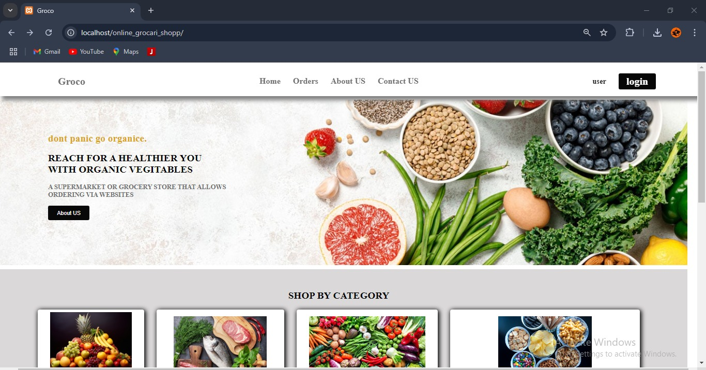

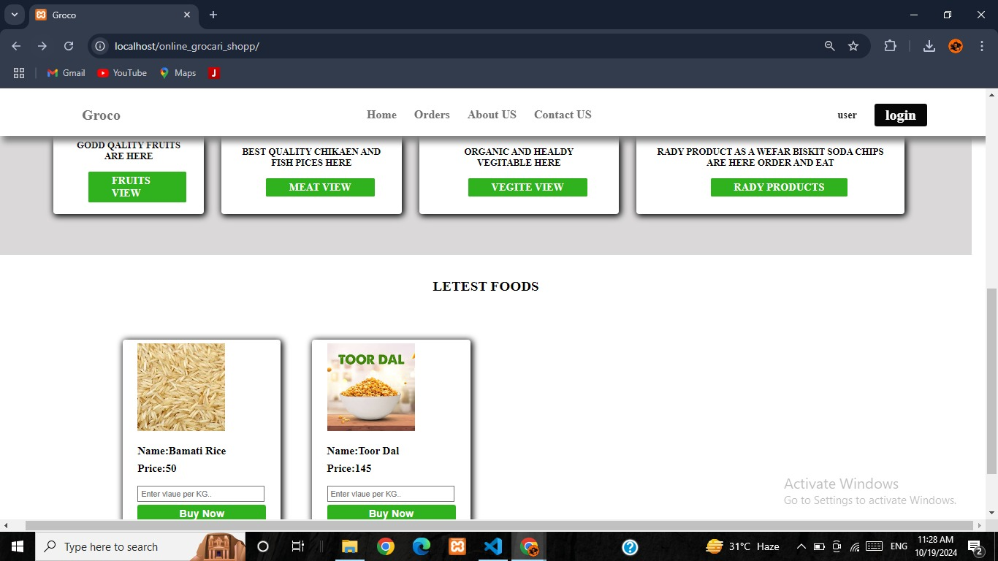

**About page :**

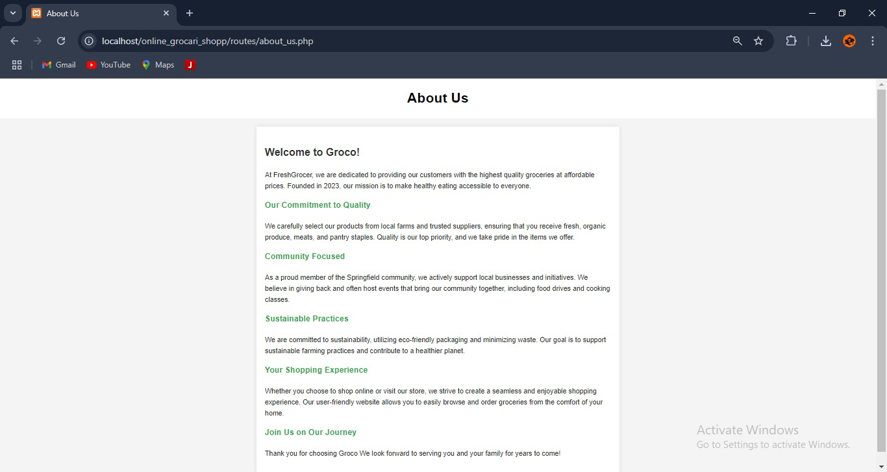

**Contact page :**

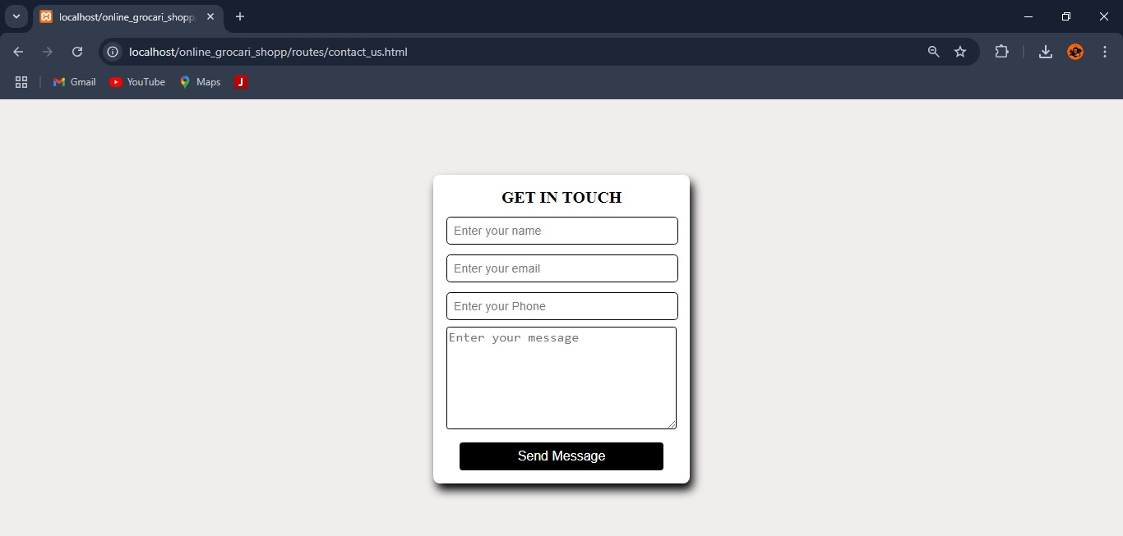

**login page :**

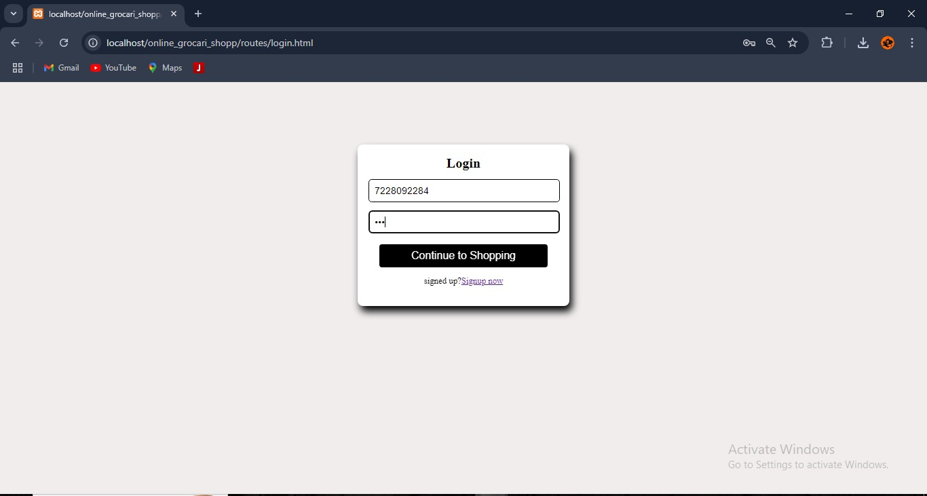

**Profile page:-**

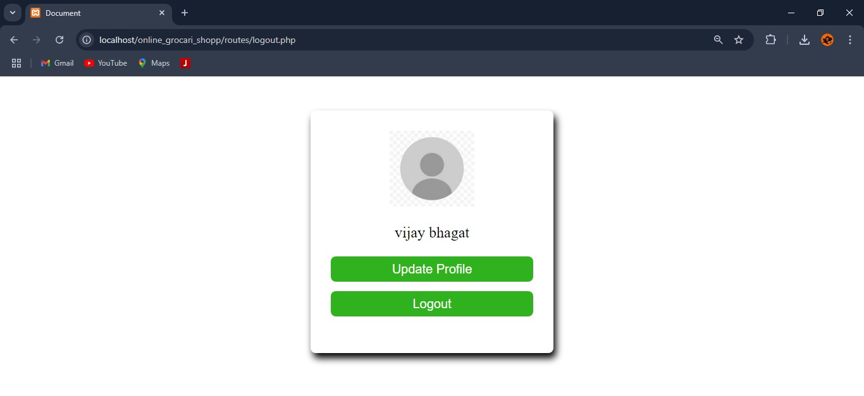

­

**Bibliography**

1. W3Schools. (2023). HTML Tutorial. Retrieved from [w3schools.com](https://www.w3schools.com/)
2. PHP Manual. (2023). PHP: Hypertext Preprocessor. Retrieved from [php.net](https://www.php.net/)
3. MySQL Documentation. (2023). MySQL Database. Retrieved from [mysql.com](https://www.mysql.com/)
4. Stack Overflow. (2023). Community-driven Q&A platform for programming. Retrieved from [stackoverflow.com](https://stackoverflow.com/)